SACRED HEART BEAT July 2016
NEWSLETTER OF SACRED HEART PARISH
1111 STATE STREET/LARNED, KS 67550-2157 ~ TELEPHONE 620-285-2035
Website: sacredheartlarned.org E-mail: office@sacredheartlarned.org

Human Development

In 2009, Pope Benedict XVII wrote CARITAS IN VERITATE, Human Development in Charity and Truth. He spoke of a “good” for all those in society, a good sought not for its own sake but for all peoples in the community. To desire the common good is a requirement of justice and charity.

Some people think they are self-sufficient and can eliminate evils in the world by their own convictions. Truth is a gift, not something we produce. Charity in truth builds community and brings all people together. Economic activity cannot solve all problems by commercial logic, but the common good can be achieved only by keeping the common good in mind.

The Church teaches that her social doctrines can become paramount only when justice is applied to every kind of economic activity. These are some of the ways that the Church offers to promote human dignity:
- Give sufficient wages and good working conditions to all employees
- Divest from companies that discriminate on the basis of race, gender, or ethnicity
- Encourage companies that make affordable life-sustaining drugs
- Do not invest in companies that have a prurient interest in sex
- Avoid investing in companies that produce military weapons and landmines
- Do not invest in sweatshops
- Invest in the protection of the environment
- Defend the primary role of the family in areas of sexuality
- Purchasing is always a moral act

The right intention, transparency, and the search for positive results are mutually compatible and must never be detached from one another. (Carita in Veritate)

Correction to last month’s article
Option for the Poor and Vulnerable

“Who profits when no one tills and cares for the earth?”

“The poor and the vulnerable.”

JULY AT A GLANCE
July 4 ~ Independence Day – Parish Office Closed
July 5 ~ Knights of Columbus Meeting, 7:00 PM
July 5 ~ Choir Practice, 7:00 PM, Choir Loft
July 10 ~ Parish Outreach Meeting, 11:45 AM
July 10 ~ Altar Society Meeting, 5:00 PM
July 12 ~ Choir Practice, 7:00 PM, Choir Loft
July 13 ~ PSR Commission Meeting, 6:30 PM
July 14 ~ Stewardship Council Meeting, 6:30 PM
July 18 ~ Heart to Heart Ministry Meeting, 6:30 PM
July 19 ~ Finance/Property Meeting, 12:00 Noon
July 19 ~ Liturgy Commission Meeting, 5:30 PM
July 19 ~ Choir Practice, 7:00 PM, Choir Loft
July 20 ~ Adoration, 5:00 to 6:00 PM
July 21 ~ Pastoral Council Meeting, 6:30 PM
July 24 ~ Parish Server Appreciation Meal, 6:00 PM
July 26 ~ Choir Practice, 7:00 PM, Choir Loft

July 28 ~ PSR Commission Meeting, 6:30 PM

May 2016 FINANCES
INCOME:

Collections 17,184.72
Special Donations
Endowment

Interest 1.68
Farm 293.36
PSR 323.50
Fundraisers
Miscellaneous 918.00
TOTAL $18,721.26
EXPENSES:

Stewardship 1,655.87
Salaries 11,829.91
Insurance 1,699.00
Utilities 2,005.81
Maintenance 977.01
Improvement
Office 1,366.96
PSR 2,892.95
Farm
Miscellaneous 1,391.67
TOTAL $23,819.18

FINANCE/PROPERTY COMMISSION
- Met June 21st
- Members present: Bob Haymaker, Dennis Wilson, G.L. VonFeldt, Jim
Damm, Leon Sanders, Jacques Molleker, Kathy Couchman, Pam Hutfles
& Fr. Warren.
Unable to attend: Connie Mauney & Don Jensen.
- Minutes of the May, 2016 meeting were approved as presented.
- The group reviewed the financial report for May reflecting
$18,721.26 in income and $23,819.18 in expenses for a deficit of
$5,097.92. The balance sheet showed assets of $442,006.39 compared
to $898,757.48 at the end of May 2015.
- The PKMR Company has completed the lighting plan for the Church. The
plan has been presented to Haynes Electric. We are waiting to hear from
Jim Haynes regarding costs, etc.
- Currently we have three modems, one in each building for internet. This
makes our bill from Cox more expensive. We are waiting on a proposal to
network all three buildings which will decrease the cost.
- Next meeting: July 19, 2016 @ 12:00 Noon

HEART TO HEART MINISTRY
- Met June 20th
- Members present: Kathy Kazmaier, Barbara Hammond, Ray
Colglazier Volunteers attending: Mary Klinge, Melinda Axman,
Sally Dreiling, Lee Gilcris.
- Minutes from the May, 2016 meeting were approved.
- Finalized plans for the Cupcake project. Cupcakes will be taken
to residents at Diversicare, Country Living, and our home bound
parishioners for the 4th of July. The youth volunteers will be invited to
participate in the decorating and delivering.
- Rita O’Gwin continues with the monthly card project to parishioners in
need of prayer. Barbara read a thank you note from a parishioner that
was given transportation to a doctor’s appointment.
- Next meeting: July 18, 2016 @ 6:30 PM

PASTORAL COUNCIL
- Did not meet June 16th
- Members: Matt Stucker, Dennis Theis, John Kelty, Berny Unruh,
Philip Hammeke, Stephen Schartz, Fay Murphy.
- Next meeting: July 21, 2016 @ 6:30 PM

PARISH OUTREACH COMMISSION
- Met June 12th
- Members present: Toni Novotny, Tami Keenan, Ann Ellis, Kristin
Hammeke & Fr. Warren. Unable to attend: Brian Haberman &
Gretchen Whittington.
- Father’s Day gifts were handed out following both Masses June 18/19.
- The commission helped with the parish potluck on Sunday, June 19th to
kick off Totus Tuus week.
- Next meeting: July 10, 2016 @ 11:45 AM

7th thru 12th Grades
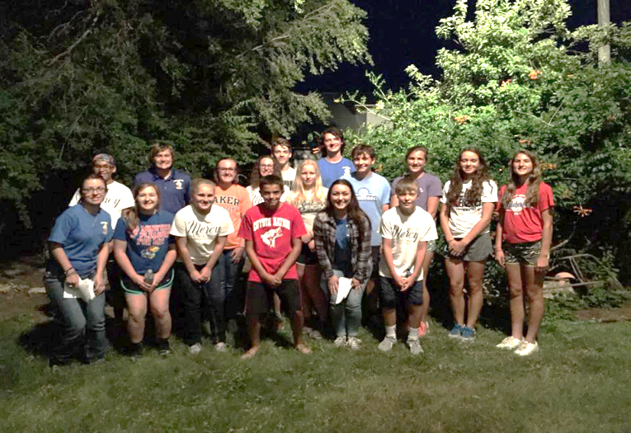

SACRED HEART PARISH
LEADERSHIP

JULY 2016 – JUNE 2017

Pastoral Council Endowment Board
Amy Froetschner Dana Bauer
Philip Hammeke Cindy Colglazier
John Kelty Judy Damm
Jeff Murphy Stan Durler
Stephen Schartz Brian Hammeke
Dennis Theis Troy Langdon
Berny Unruh Ray Moeder

Stewardship Council Outreach Commission
Elaine Coulson Ann Ellis
Don Kazmaier Brian Haberman
Mary Klinge Kristin Hammeke
Brenda Langdon Tami Keenan
Mary Mitchell Toni Novotny
Kristy Mull Gretchen Whittington
Shane Sundahl

Liturgy Commission Finance/Property Commission
Melinda Axman Kathy Couchman
Linda Befort Jim Damm
Lee Durler Bob Haymaker
Sherry Lemuz Don Jensen
Sharon McGinness Connie Mauney
Janet Skelton Jack Molleker
Mary Smith Leon Sanders
G.L. VonFeldt
Adult Religious Dennis Wilson
Formation Commission
Diane Dodez PSR Commission
Regis Lopata Kathy Hammeke
Mary Mitchell Michelle Kelty
Sr. Rebecca Otter Jim Mitchell
Kristy Mull
Heart to Heart Ministry Ben Ramsey
Ray Colglazier Stacy Sanger
Barbara Hammond Krysten Watkins
Kathy Kazmaier

1st thru 6th Grades
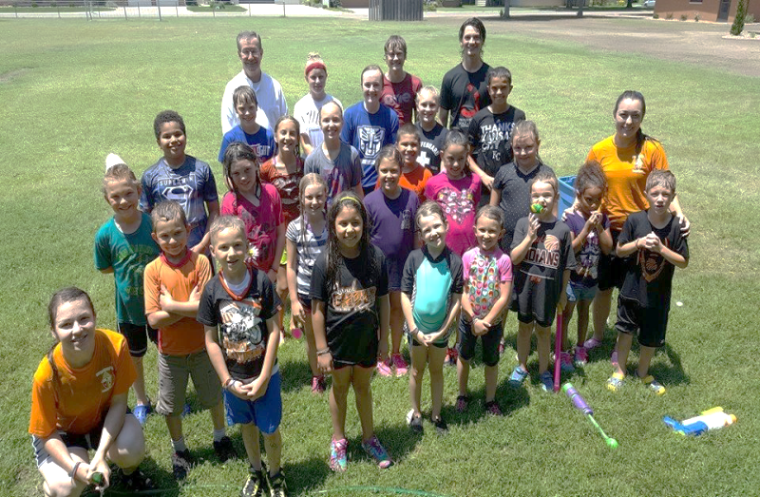

Totus

Tuus

Week


July Birthdays
(01) Ray Moeder (17) Melinda Axman
Alex Sanger Regan Carlson
(02) Doug McNett Alexis Langdon
Theresa Medina Bob Larsen
(03) Randy Bird (18) Ethan Banman
Tamber Colglazier Annie Garcia
Gary Levins Cody Keenan
(04) Steve Martin Shauna Nwachukwu-Udaku
(05) Royce Froetschner (20) Rod Bauer
Edgar Ramirez Brian Haynes
(06) Michael Orth Joyce Henderson
Phillip Perez Doris Schaller
Grant Watkins Richard Wolf
(07) Charlie Danler (21) Matt Fisher
Blake Holmes Tyson Steffen
(08) Joe Hammeke (22) Trevor Bartz
Trenton Welsch (23) Linda Goeken
(09) Trinity McAlister-Weiszbrod Bruce Kozlowski
Jane Zook (25) Deacon Martin
(11) Avion Tucker (26) Sandi Bartz
(13) Margaret Grant Eian Sanders
Mason Schartz (27) Terri Bauer
(14) Loraine Hammeke Jameson Smith
Christian Jensen (28) Slade Sundahl
Katelynn Sanger (29) Diane Walker
(15) Ava Flores (30) Brad Herter
(16) Bryan Fischer Ralph Martin
Becky Martin (31) Mary Lou Frisbie
Celine Hall
Dominic Pelaccio

Remember with Prayer

Coletta Meier Elora Robinson
Mary Schartz Pat Thompson

Fheno Perez Hazel Callahan

Maxine Ackerman Mickey Perez
Grace Perez Mary Ann Schartz
Phyllis Neidig Clayton Kelty
Kindra Perez Amy Herter
Jayden Waller Catherine Orth
John Harmon Joyce Greathouse
Sharon Larsen Frank Callahan
Betty Tauscher Sr. Clara Ann Fluech
Fr. Warren Stecklein Ryan Shelton
Fr. Charles Mazouch Bob Brack
Pat Barrett

All of our men and women serving in the
United States military

Knights July Events
July 5 . . . . . . . Knights of Columbus Meeting, 7:00 PM
July 16 . . . . . . American Legion Dinner (G)
July 24 . . . . . . Parish Server Appreciation Meal (R)
July 30 . . . . . . Anniversary Dance (G)



Sacred Heart
Altar Society Meeting

Sunday, July 10th

5:00 pm
Parish Education Center

July Anniversaries
(02) Don and Kathy Kazmaier
(05) John and Jane Kelty
Doug and Mary Smith
(07) Mike and Julie Snyder
(08) Eric and Nicki Roof
(09) Jim and Lynn Ryan
Shane and Wendy Sundahl
(11) Ty and Kayla Josefiak
(17) Josh and Abby Holmes
Richard and Colleen Wolf
(18) Brad and Shelley Bauer
(19) Brandon and Jennifer Turner
(21) Jeff and Fay Murphy
(22) Troy and Brenda Langdon
(26) Clint and Autumn Millan
(29) Jared and Tisha Skelton


CONGRATULATIONS!

Richard & Colleen Wolf ~ Married 45 years


UNITED IN MARRIAGE

John Wasinger & Jacque Johnson
June 24, 2016

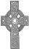

DIED IN CHRIST
Helen M. Finger ~ June 10, 2016

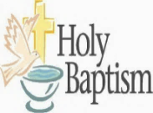
BAPTIZED IN CHRIST

Waco Douglas, the son of
Weston & Samantha Jacobs
June 18, 2016

╪ RCIA ╪

The sessions of the Rite of Christian Initiation of Adults will begin in September. If you know of anyone who might be interested in inquiring into the Catholic faith, please extend an invitation. The first several weeks will be spent in answering questions of inquirers and does not mean there is an obligation to join the church. These sessions may also be informational for Catholics who want an update about their faith. For further information, please call Regis Lopata at 285-2684 or the parish office at 285-2035.

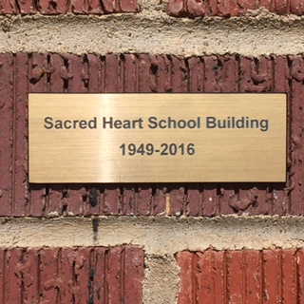
Sacred Heart School Building
1949-2016
Sacred Heart School Building bricks will be made available with the remembrance plaque as shown on this picture. If you would like to have one or more, please call or email the parish office to have your name put on the list. A donation of $2.50 will cover the cost of the plaque.

ACRED HEART PARISH
1111 STATE STREET
LARNED, KS 67550

Return Service Requested

Non Profit Org.
Bulk Rate
U.S. Postage

PAID
Larned, KS 67550
Permit No. 41



