SACRED HEART BEAT DECEMBER 2016
NEWSLETTER OF SACRED HEART PARISH
1111 STATE STREET/LARNED, KS 67550-2157 ~ TELEPHONE 620-285-2035

Website: sacredheartlarned.org E-mail: office@sacredheartlarned.org

“The Joy of Love” Chapter 2

The Experience and Challenge of Families

Family life has lights and shadows. Freedom of choice for family members allows one to plan lives and make the most of ourselves; yet this freedom can degenerate into the inability to give oneself generously to others. There are many countries where people choose to live alone and refuse to have children. It is possible to set aside stability when it is inconvenient. Pope Francis believes it is the duty of the teaching church to give good reasons and motivations for choosing marriage and family as the way to help men and women respond to the grace God offers them.

Our Christian beliefs about marriage need a good dose of self-criticism. The unitive meaning of marriage and its call to love and mutual assistance can be overshadowed by the insistence of this duty of procreation. Good norms of guidance on young couples’ timetable and an artificial ideal of marriage do not propose practical possibilities of real families.

Pope Francis admits that some do not encourage openness to God’s grace and they stress instead an almost artificial ideal of marriage, but marriage must be seen as a path to personal fulfillment and not a lifelong burden. “At times we don’t allow time for conscience development and response to the Gospel. We are called to form conscience, not replace it.”

Preparation for married life must be based on the power of grace experienced in the sacrament of reconciliation and in the Eucharist. Preparation for marriage must also include reflection, sacrifices, and forgiveness of one another. The new theology which can include ways to make babies or not make them, make according to one’s pattern, to delay or rush pregnancies---all these provide ‘bumps in the road” to a Christian way of life.

Here are some hurdles to be overcome in the family according to Pope Francis:
- Preplanning for affordable housing
- Sickness and lack of insurance can pressure the young family
- Migration and human trafficking can cause human trials
- Children with special needs require much assistance
- Elderly parents to be cared for can be an inconvenience to families

Pope Francis said, “I thank God that many families which do not consider themselves perfect, live in love, fulfill their calling, and keep moving forward even if they fail many times along the way.”

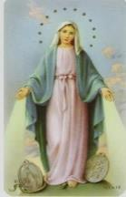
The Immaculate Conception of the
Blessed Virgin Mary
Thursday, December 8th
Masses:
7:00 am at St. Bernard, Belpre
6:30 pm at Sacred Heart

Christmas Schedule

Christmas Eve Masses ~ December 24th
4:00 pm at Sacred Heart, Larned

6:00 pm at St. Bernard, Belpre

Christmas Day Mass ~ December 25th
9:00 am at Sacred Heart, Larned

Solemnity of Mary, The Holy Mother of God
5:00 pm – Saturday – December 31 at Sacred Heart
8:30 am – Sunday – January 1 at St. Bernard, Belpre
10:30 am – Sunday – January 1 at Sacred Heart

DECEMBER AT A GLANCE

Dec. 1 ~ Adult Religious Formation Meeting, 7:00 PM
Dec. 6 ~ Knights of Columbus Meeting, 8:00 PM
Dec. 6 ~ Choir Practice, 7:00 PM, Choir Loft
Dec. 7 ~ PSR Classes (Gr. K-8), 6:00 to 7:30 PM
Dec. 7 ~ PSR Class (Gr. 9-12), 6:30 to 8:00 PM
Dec. 7 ~ Pick up Zak’s Cheese orders
Dec. 7 ~ RCIA, 7:00 PM
Dec. 8 ~ The Immaculate Conception of the Blessed Virgin Mary
Masses: 7:00 AM, St. Bernard, Belpre – 6:30 PM, Sacred Heart
Dec. 8 ~ Stewardship Council Meeting, 7:30 PM
Dec. 10 ~ Christmas Pageant & Light Meal following 5:00 PM Mass
Dec. 11 ~ Parish Outreach Meeting, 11:45 AM
Dec. 13 ~ Choir Practice, 7:00 PM, Choir Loft
Dec. 14 ~ PSR Classes (Gr. K-2), 6:00 to 7:30 PM
Dec. 14 ~ Advent Penance Service, 6:30 PM
Dec. 14 ~ PSR Classes (Gr. 3-12), attend Advent Penance Service
Dec. 14 ~ RCIA, 7:00 PM
Dec. 15 ~ Pastoral Council Meeting, 6:30 PM
Dec. 19 ~ Heart to Heart Ministry Meeting, 6:30 PM
Dec. 20 ~ Finance/Property Meeting, 12:00 Noon
Dec. 20 ~ Choir Practice, 7:00 PM, Choir Loft
Dec. 21 ~ PSR Classes (Gr. K-8), 6:00 to 7:30 PM
Dec. 21 ~ PSR Class (Gr. 9-12), 6:30 to 8:00 PM
Dec. 21 ~ NO RCIA
Dec. 27 ~ Choir Practice, 7:00 PM, Choir Loft
Dec. 28 ~ NO PSR Classes (Gr. K-12), Christmas Break
Dec. 28 ~ NO RCIA

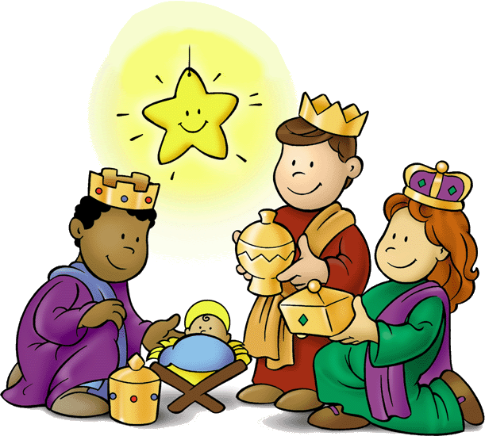
Christmas Pageant
On Saturday, December 10th following
the 5:00 pm Mass our PSR youth will be performing their Christmas Pageant in church followed by Hot Dogs & Hamburgers at the Parish Education Center. A free will offering is appreciated. All are invited to attend this festive Pre-Christmas event.

FINANCE/PROPERTY COMMISSION
- Met November 15th
- Members present: Bob Haymaker, Dennis Wilson, G.L. VonFeldt, Jim
Damm, Don Jensen, Leon Sanders, Jacques Molleker, David Zecha,
Connie Mauney, Kathy Couchman, Pam Hutfles & Fr. Warren.
- Minutes of the October, 2016 meeting were approved.
- The group reviewed the financial report for October reflecting
$21,122.21 in income and $18,038.14 in expenses for a net income of
$3,084.07. The balance sheet showed assets of $286,862.62.
- The exterior lights at the church are done. One of the chandelier lights
above the naïve of the church was changed to LED bulbs which emitted
much more light. All the remaining chandelier lights will be changed to
LED bulbs in the near future.
- Central Plains Computer Services have completed networking the three
buildings.
- David reported on the address signs for the parish buildings. It was moved and seconded to purchase matching signage for the Parish Center (stainless steel) and use cast aluminum for the Parish Annex and Rectory at a cost of $1,131.00.
- Two benches for the patio in front of the Parish Center have been ordered. They will be rose colored granite benches which will be purchased with memorial donations.
- It was moved and seconded to reinstate the monthly stipend for the Helping Hands/Food Pantry directory pledged previously by Sacred Heart. This will be retroactive to July and monthly here forward.
- Next meeting: December 20, 2016 @ 12:00 Noon

STEWARDSHIP COUNCIL
- Met November 10th
- Members present: Mary Klinge, Mary Mitchell, Brenda Langdon, Don
Kazmaier, Kristy Mull, Elaine Coulson, Shane Sundahl, Sr. Rebecca &
Fr. Warren.
- Minutes from the October, 2016 meeting were approved.
- Reviewed the Fall Festival. Had positive comments.
- Stewardship forms: 88 adults and 12 children have been received. It
was suggested contacting parishioners who have signed up for a new
ministry to make personal arrangements for the training. Mary M.
volunteered to work on a job description/checklist for ministries to be
placed in church.
- The Stewardship spreadsheet has been revised.
- Next meeting: December 8, 2016 @ 7:30 PM

PASTORAL COUNCIL
- Met November 17th
- Members present: Dennis Theis, Philip Hammeke, Amy Froetschner,
Stephen Schartz, John Kelty, Sr. Rebecca & Fr. Warren. Unable to
attend: Berny Unruh & Jeff Murphy.
- Minutes of the October meeting were approved.
- Fr. Warren updated the council on the Vibrant Ministries Campaign. He
noted that the Pastoral and Finance committees will work together on
this project. He encouraged the council to follow the SWKC on the
progress being done in the pilot parishes.
- Fr. Warren reported that Tom Giessel and Dave Zecha have completed
the playground. Benches were placed under a tree for shade. Pea
gravel was put down under the play equipment.
- The PSR Committee has drafted a CRE (Coordinator of Religious
Education) Job Description. Copies were given to each council
member to review and bring back their thoughts at the December
meeting.

- Next meeting: December 15, 2016 @ 6:30 PM

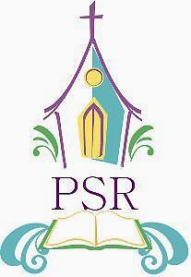
PSR NEWS

The month of November and December
are busy times in everyone’s lives and it is
no different in Sacred Heart’s Parish School of Religion. We began the month celebrating All Saints and All Souls Days learning about the holy days and a little about a few of the saints. We have estimating jars where the students put their best guess of how much is in each jar and the winner will get to bring a prize home before Christmas break. Each estimate jar represents a saint and includes a history of that saint’s life. Everyone is welcome to come and take a look at all of the various saints the students are learning about.

We also completed our Zak’s cheese sales and because most of the students successfully turned in their forms as asked, many filled with an amazing number of orders and some blank; we will have a popcorn and game party on January 11th to celebrate. Our game will be trivia based focusing primarily on the Ten Commandments.

The high school youth completed their fundraiser at Carr Auction and have now moved on to selling fresh made Spears pies. These pies can be ordered through a high school youth or through the parish office. The youth will meet for the first time in November about their March for Life trip and will leave for the trip at the end of January.

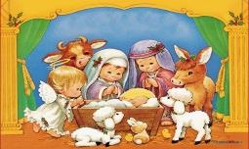
Finally Kindergarten through the eighth grades have been preparing for their annual Christmas Pageant. They have been memorizing lines and practicing songs in hopes for a successful evening of Christmas joy. The pageant will be after the evening Mass on December 10th and will be followed by a hamburger and hot dog feed put on by the high school students in the parish education center. Everyone is invited!!

Christmas Blessings!!!

The PSR Committee

HEART TO HEART MINISTRY
- Met November 21st
- Members present: Kathy Kazmaier, Mary Klinge, Melinda Axman, Sally
Dreiling, Barbara Hammond, Ann Haremza.
- Minutes from the October, 2016 meeting were approved.
- Cupcakes were delivered for Veteran’s Day to residents of Country
Living, those on our home communion list, parishioners at home
needing a “lift”, and some of our veterans.
- Cupcakes will be provided for the PSR Classes on December 21st
following their program at Diversicare and Country Living.
- Next meeting: December 19, 2016 @ 6:30 PM


December Birthdays
(02) John Hutfles (17) Shannon Fischer
Darlene Medina Sr. Irene Hartman
Nicholas Orth Abby Kelty
(03) Alexandra Moscoso (19) Tom Bahr
Brandon Turner Jamie Froetschner
(04) Brandon Ceniceros Kevin Hammeke
Mary Schartz Kelsey Parr
(05) Mike Mauney Malia Schartz
(06) Stephen Heit (20) Brad Bauer
(07) Gretchen Holopirek Monica Clark
Alexis Kimble Felicity Newell
(08) Troy Langdon (21) Cade Parr
(10) Mary Mitchell Joe Simmons
Bryan Schroeder Richard VonFeldt
Janice Schroth (22) Jessie Weiszbrod
(11) Linda Lemuz (23) Vi Prosser
Jeanie Snyder (25) Gustavo Flores
(12) Trenton Fletcher (26) Jean Simmons
Cindy Perez (27) Alec Carlson
(13) Kristin Dooley (28) Terri Bahr
Natalie Stude Finley Froetschner
(14) Kathy Hammeke Mary Klinge
Betty Hulsey Liz McDonald
(15) Retha Delgadillo Brylee Medina
(16) Becky Dodez (30) Danielle Chilcott
Kristin Hammeke (31) Brayson Bird
Karen Kuntz Kayla Josefiak
Jeremy McDonald Marissa Smith
Amy Welsch

Remember with Prayer

Mary Schartz Betty Tauscher
Fheno Perez Dorothy Edmonds

Pat Barrett Hazel Callahan

Maxine Ackerman Mickey Perez
Grace Perez Mary Ann Schartz
Phyllis Neidig Clayton Kelty
Frank Callahan Amy Herter
Jayden Waller Catherine Orth
John Harmon Joyce Greathouse
Sharon Larsen Frank Callahan
Fr. Warren Stecklein Sue Haymaker
Fr. Charles Mazouch Ryan Shelton
Norma Delaney Terry Perez

All of our men and women serving in the
United States military

Knights December Events
Dec. 1 . . . . . . . . Life Hunt Dinner (R)
Dec. 2 . . . . . . . . PVCH Christmas Party (G)
Dec. 6 . . . . . . . . Knights of Columbus Meeting, 7:00 PM
Dec. 9 . . . . . . . . Pawnee County Coop Christmas Party (R)
Dec. 10 . . . . . . . Ward Feed Yard Christmas Party (G)

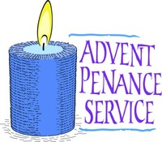
WEDNESDAY
DECEMBER 14TH
6:30 PM
Sacred Heart, Larned

Sunday, Dec. 11th ~ 4:00 pm @ St. Rose, Great Bend
7:00 pm @ St. Patrick, Great Bend
Tuesday, Dec. 20th ~ 7:00 pm @ St. Nicholas, Kinsley

December Anniversaries
(01) Henry and Kristen Snodgrass
(03) Phil and Ann Schreiber
(04) Frank and Linda Garcia
Mike and Connie Mauney
David and Stacy Sanger
(19) Doug and Jennifer McNett
(25) Jim and Sharon McGinness
(28) Joe and Annie Garcia



CONGRATULATIONS!

Frank & Linda Garcia ~ Married 40 years
Mike and Connie Mauney ~ Married 40 years



UNITED IN MARRIAGE

Andrew Froetschner & Erica Milhon
November 19, 2016

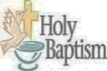
BAPTIZED IN CHRIST

Cooper Wayne, the son of
Stephanie Burd ~ November 13, 2016

OCTOBER 2016 FINANCES
INCOME:

Collections 16,931.43
Special Donations
Endowment

Interest 1.59
Farm
PSR 1,513.50
Fundraisers 1,152.19
Miscellaneous 1,523.50
TOTAL $21,122.21

EXPENSES:

Stewardship 1,713.11
Salaries 10,139.52
Insurance 1,699.00
Utilities 1,617.20
Maintenance 195.91
Improvement
Office 1,010.21
PSR 662.41
Farm
Miscellaneous 1,000.78
TOTAL $18,038.14

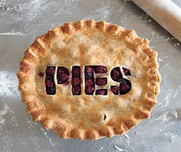

OUR SACRED HEART YOUTH GROUP
is having a Christmas Fundraiser.
They will be selling Spear’s Pies
(9” Deep Dish: Apple, Cherry, Pecan, Pumpkin, Chocolate Cream, French Silk, Coconut Cream, Lemon Meringue, Cherry Cheesecake) for $15 each. Pie pick up will be at the Sacred Heart Education Center from 3-6 pm on December 23rd. If you aren’t contacted by a High School youth and would like to make a purchase, please call the Parish Office at 285-2035.

ACRED HEART PARISH
1111 STATE STREET
LARNED, KS 67550

Return Service Requested

Non Profit Org.
Bulk Rate
U.S. Postage

PAID
Larned, KS 67550
Permit No. 41

